**Ms. Rakheeba Taseen, Manoj Yadav N, Nandini Desai, Greeshma S Devadiga**

1Asst. Professor, School of CSE, Presidency University, Bangalore, India.

2,3,4B. Tech Final Year Students, Computer Science Engineering,

Presidency University, Bangalore, India.

[rakheeba.taseen@presidencyuniversity.in](mailto:rakheeba.taseen@presidencyuniversity.in), [manojyadavnvk@gmail.com](mailto:manojyadavnvk@gmail.com), [nandinidesai2002@gmail.com](mailto:nandinidesai2002@gmail.com),

[devadigagreeshma@gmail.com](mailto:devadigagreeshma@gmail.com)

**Automated Vehicle Entry and Exit Management for Residency**

*Abstract*- In the ever-evolving realm of urban living, our mission is to enhance the safety, security, and overall ease of residency within neighborhoods. Imagine a smart system that acts as a friendly guardian, efficiently managing residency in a manner that prioritizes safety and security. It is not just about technology; it is about creating a harmonious living experience. Our ingenious system employs advanced license plate recognition technology to swiftly identify and welcome residents' vehicles while maintaining a watchful eye on arrivals and departures. It is akin to having a digital concierge who knows everyone by name, ensuring that only authorized individuals have access. This does not just heighten neighborhood security but also eases congestion by allowing only approved vehicles through. We are not just focused on security; we are dedicated to crafting a living experience that revolves around your safety and convenience. Through a blend of artificial intelligence and data-driven insights, our system tailors its approach to your preferences, making your daily life a breeze. Think of it not merely as a residency management system but as a reliable companion, adapting to your lifestyle and contributing to the sense of community in modern urban living. We are not just embracing technology; we are creating a future where neighborhoods are not only safer but also feel more like a secure and welcoming home. Because, in the end, it is not just about managing residency; it is about making life in your community safer, more secure, and significantly more enjoyable.

Keywords— Vehicle Entry and Exit, OCR, Android Platform, Firebase, Residency Management, Number Plate Recognition, Automated System.

# **INTRODUCTION**

When it comes to contemporary residence management, the increasing number of cars on the road demands creative fixes. Introducing "Automated Vehicle Entry and Exit Management for Residency," an innovative method that leverages Android's Optical Character Recognition (OCR). The system prioritizes security and real-time data updates with seamless Firebase connection to optimize entrance and exit procedures. The approach, which shows notable gains in residency security, combines image capture, OCR implementation, number plate extraction, and user interface design. The DriverClass application integration improves functionality and provides a comprehensive solution to transform modern residency management.

# **RELATED WORD**

## Plate Detection

License plate discovery may be a critical stage in vehicle recognition frameworks, and the method includes deciding the range of interest (ROI) where the permit plate is likely to be found on a vehicle. The writing paper titled "Vehicle Permit Plate Acknowledgment Utilizing the Super-Resolution Method" sheds light on the stages included in this vital angle.

According to the paper, license plate location can be categorized into four primary strategies [2]. The primary approach utilizes color as the key quality for location. In this strategy, the framework analyzes the color characteristics of the picture to distinguish locales that are likely to contain permit plates. Color-based location is compelling in scenarios where permit plates have distinct color designs.

The moment strategy depends on edge characteristics to rummage around for the authorizing square inside the picture. This approach includes distinguishing edges and forms within the picture, as permit plates regularly have edges that can be recognized. Edge-based location is especially valuable when managing with pictures, where they differentiate between the permit plate and the foundation is well-defined.

Inside the distinguished ROI, the calculation assist localizes the exact position and limits of the permit plate. This localization is significant for accurately extracting the permit plate data from the picture.

The third strategy includes a looking work based on characters specifically within the picture. In this approach, the framework looks for character designs that take after permit plate characters inside the picture. This strategy is successful when managing with varieties of permit plate plan and character situation.

The fourth category includes other miscellaneous strategies not secured by the past three. These seem to incorporate cross-breed approaches or inventive methods that use different perspectives of color, edges, and characters to permit plate discovery.

## Character Recognition

Character recognition is a core part of digital recognition systems and is handled in two ways: using raw data or extracting features. This is discussed in the article "Vehicle number plate recognition with super-resolution technology". The raw data includes pattern matching in binary images suitable for fixed-size undistorted tiles. [2] Feature-based detection improves accuracy by using techniques such as mean deviation, edge detection, Gabor filters, and subblock gray value analysis. This dual approach ensures accurate license plate character recognition, which is crucial for applications such as vehicle tracking and access control.

## Database Management

Many mobile applications show the complexity of database access, security, and speed. Developers typically use inadequate APIs and techniques to execute SQL commands, leading to preventable SQL injection vulnerabilities. The literature paper, "An Empirical Study of Local Database Usage in Android Applications" [5] addresses the use of untrusted inputs as an additional SQL injection risk. Database startup and write functions are extremely resource-intensive, and improperly orchestrating them inside loops without adequate buffering results in significant resource consumption and inefficiency. These results provide important insights and highlight the need for developers to pay attention to security and performance optimization when designing and deploying mobile applications.

## The Design of Notification

Research made in the paper "Unified platform for the delivery of notifications to smartphones [6] demonstrates the presence of a primary design of the framework that emphasizes the utilization of stateless intuition and the thought of express state exchange. It shows that various information designs are conceivable, although the preference is given to JSON. The paper too briefly touches on the security component, emphasizing the utilization of HTTP Process verification with HTTPS/TLS.

## OCR and Tesseract

Within the over paper the method of optimizing content extraction from pictures, covering strategies for taking care of loud pictures captured from versatile gadgets, changing over color pictures to grayscale, and utilizing limits for content piece recognizable proof. It clarifies strategies such as disintegration and enlargement operations for clamor decrease and character improvement, as well as the application of nearby strategies for binarization. The generally center is on the specialized steps included in extricating content from pictures, counting the utilize of calculations and operations to move forward execution. OpenCV and the Tesseract motor are crucial to the improvement of the show [10]. OpenCV libraries play a significant part in proficient picture preparing, sparing programming time, and encouraging steps such as permit plate localization, character division, and OCR acknowledgment. Furthermore, the Tesseract motor, in conjunction with a neural arrange, is utilized for optical character acknowledgment (OCR) to change over captured permit plate pictures into machine-encoded content. These advances are basic in accomplishing the fruitful handling and extraction of content from pictures, making the Android program profoundly successful in assembly its goals.

## Use of CNN, RCNN in ALPR

The report centers on Programmed Permit Plate Acknowledgment (ALPR) utilizing Quicker R-CNN, handling challenges like variable lighting conditions and emphasizing highlight extraction's significance. It navigates Convolutional Neural Systems (CNN) for proficient highlight mapping and Region-based Convolutional Neural Systems (R-CNN) for locale proposition in ALPR [8]. CNN forms input pictures, making a convolutional highlight outline for locale proposition recognizable proof. Conventional R-CNN utilizes hunt for recommendations, affecting speed. Quicker R-CNN develops as an upgraded arrangement by disposing of specific look, altogether opening speed, and proficiency. Coordination a Locale Proposition Organize (RPN), Speedier R-CNN predicts grapples for exact question distinguishing proof. In pith, the cooperative energy between CNN and R-CNN, especially through Speedier R-CNN, hoists highlight mapping, locale proposition era, and protest distinguishing proof in ALPR [8]. This headway, complemented by picture handling and preprocessing procedures, adeptly addresses challenges, upgrading the model's execution and effectiveness in programmed permit plate discovery. The archive typifies this transformative approach to ALPR, giving a compact understanding of the collaboration between CNN and R-CNN strategies inside a brief 150-word clarification.

## Database connection using Firebase

The archive dives into leveraging Firebase for secure database associations in Android app advancement. It underscores Firebase Analytics for smart app utilization information, Firebase Cloud Informing for cross-platform communication, and Firebase Auth for consistent social login back [7]. Emphasizing Firebase's JSON information capacity and real-time database, the record highlights the utilize of child hubs for organizing client qualifications. Screenshots of a Firebase-integrated app give a visual see. The conclusion stresses the proficiency picked up by avoiding third-party dialects like PHP, confirming Firebase's part in quickening, and securing Android apps through strong database network.

## ResNet

ResNet 34, a profound leftover organizes, for vehicle number plate recognizable proof. ResNet's 34-layer engineering encourages effective highlight extraction and character acknowledgment from number plate pictures. The consolidation of remaining associations in ResNet decreases asset prerequisites for picture handling whereas holding basic data, demonstrating profitable for character acknowledgment in different natural conditions. Strikingly, the framework shows commendable precision in recognizing vehicle numbers and proprietorship points of interest, indeed for vehicles in movement at speeds of up to 10 km/h [9]. The ResNet CNN architecture's flexibility in taking care of pictures of shifting shapes, measurements, and lighting conditions is essential in guaranteeing exact location and acknowledgment of vehicle number plates.

# **Proposed method**

## Image Capture

During the first stage, high-definition pictures of car license plates are taken using the Android platform. Strategic factors like the best possible lighting and different viewing angles are carefully considered to guarantee that the OCR processing that follows is effective. The method builds a strong basis for precise recognition by giving priority to obtaining crisp and detailed photos, which accommodates a variety of conditions prevalent in real-world residence settings.

## OCR Processing

The application of sophisticated optical character recognition (OCR) techniques forms the system's foundation. These algorithms carefully extract text information from the acquired photos after being fine-tuned for peak performance. The method uses a complex interaction between machine learning and pattern recognition to dynamically adjust to changes in the formats and styles of license plate images. The OCR processing phase is the system's cognitive engine, precisely converting visual data into textual information that can be used. It does this by keeping a close eye on accuracy.

## Number Plate Extraction

The technology uses sophisticated post-OCR algorithms to extract number plates precisely. These methods include the structural components of the number plate in addition to text recognition. Plate format variations are handled by adaptive algorithms, which provide a robust reaction to the wide range of designs that may be encountered. This stage is essential for converting unprocessed OCR findings into processed, structured data, which serves as the foundation for user engagement and safe data management later.

## Text Processing

The system does extensive text processing after extracting number plates to improve and polish the information that has been extracted. To check and enhance data accuracy, this step uses post-processing techniques to address potential OCR errors and anomalies. The system guarantees the accuracy of textual data obtained from number plates by means of a methodical analysis and correction of errors. This strengthens the integrity of the data processing stages that follow.

## Firebase Integration

A key component of the system is its interaction with Firebase, which creates a quick and safe channel for managing data in real time. This includes using Firebase Cloud Functions to automate data processing, which adds to the scalability of the system. The integration ensures that the system functions as a component of a dynamic ecosystem rather than operating in isolation, enabling smooth communication between the centralized database, OCR engine, and user interface, and achieving the efficiency and security objectives of the project.

## User Interface Design

A key component of the system is its interaction with Firebase, which creates a quick and safe channel for managing data in real time. This includes using Firebase Cloud Functions to automate data processing, which adds to the scalability of the system. The integration ensures that the system functions as a component of a dynamic ecosystem rather than operating in isolation, enabling smooth communication between the centralized database, OCR engine, and user interface, and achieving the efficiency and security objectives of the project.

## Testing and Optimization

Thorough testing is the cornerstone of dependable systems. System-level tests verify overall functionality, while unit tests examine specific parts. In this iterative process, possible problems are found, algorithms are optimized, and settings are adjusted. To ensure that the system's performance is continuously enhanced and meets the needs of real-world scenarios and user expectations, testing is not a one-time event but rather an ongoing refinement process.

## Integration with DriverClass Application

The method's climax is the smooth integration of the DriverClass application with the number plate recognition system. This integration ensures compatibility and interoperability between the two systems by strategically aligning functionalities rather than just merging them technically. The project offers a comprehensive solution that goes beyond simple residency management by expanding the system's capabilities through integration, improving overall operational efficiency and user experience.

# **System Architecture**

## User Interface and Functions

### Alert Display: In the event that the license plate is not registered with the system, this component oversees informing users through alerts or notifications. It makes certain that users are made aware of any inconsistencies with the automobiles that are registered.

### Home Page: The application's landing page gives users access to its main features, which include admin login and number plate scanning. It acts as the focal point of communication amongst users.

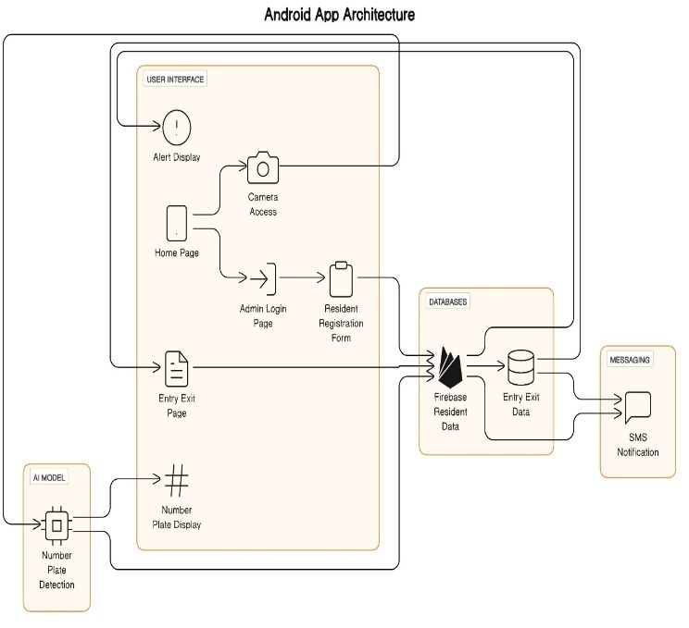

Fig 1.1 System Architecture

### Admin Login Page: This page allows authorized staff to access features that are unique to administrators. Access to the Resident Registration Form, where new residents can register with the system, is provided after a successful login.

### Resident Registration Form: This interface makes it easier for new residents to register and enter their relevant data into the database. It connects to the Firebase Resident Data to store and retrieve resident data, and it allows the system's resident database to grow.

### Camera Access: This makes it possible to use the device's camera to detect licence plates. It is connected to the Firebase Resident Data for retrieving pertinent resident information and to the AI model for number plate identification.

### Entry Exit Page: This page keeps track of and shows vehicle entry and exit information. The vehicle movements within the residence are accurately tracked thanks to its connection to the Entry Exit Data database.

## AI Model

### Number Plate: This feature uses an AI model to identify and locate number plates in the live video stream. It permits the system to recognise and handle information from licence plates to perform additional functions, including entry/exit recording or resident verification.

### Detection: This part oversees displaying the identified number plate after it has been detected. It fills in the space between the display interface for system and user reference and the AI model's recognition.

## Databases

### Firebase Resident Data: This database houses and administers details about the system's registered residents. It acts as a central repository for resident data, making it possible to store and retrieve resident data efficiently.

### Entry Exit Data: The registered vehicle's entry and exit events are tracked in this database. Efficient management and monitoring are made possible by the accurate tracking and documentation of vehicle movements within the residency.

## Messaging

### SMS Notification: This part oversees informing registered residents via SMS when their car moves within the residency. It improves communication and informs homeowners about what their vehicles are doing on the property.

# **RESULT**

## Home Page

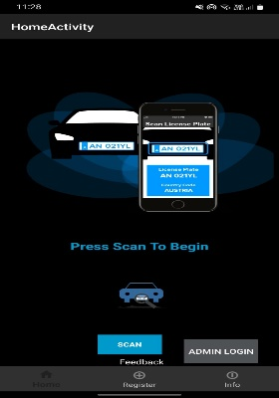

Fig 1.2: Home Page

User can either navigate to the scan page for scanning the number plate or can navigate to the admin login page for further registration of number plate to the database.

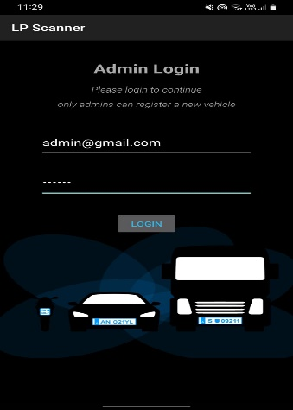 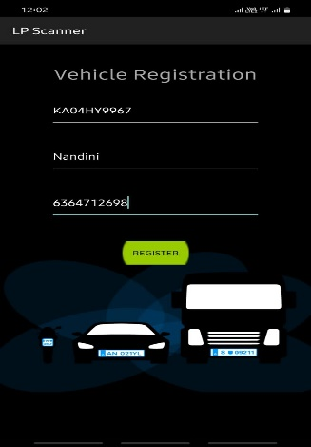

Fig 1.3: Admin Login Page Fig 1.4: Registration Page

## Number Plate Scanning

OCR software effectively recognizes and extracts text from photos, especially license plates. Real-time text detection is presented on the program interface.

If the number plate is registered in the database, it displays entry and exit records of that vehicle, and if the vehicle number plate is not registered it gives an alert message saying “Vehicle not registered.”

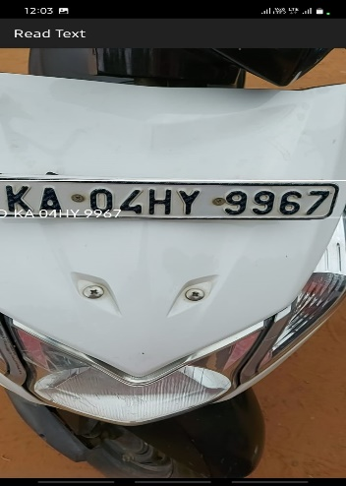

Fig 1.5: Scanning of number plate Fig 1.6: Alert message

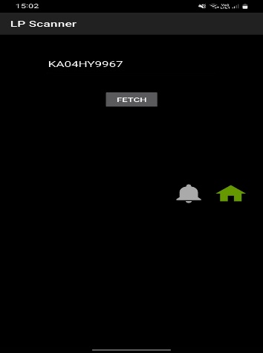

Fig 1.7: Fetching data from database Fig 1.8 Entry/Exit Log

## SMS notfication

Once the records are fetched for the number plate, application sends a SMS message to the registered phone number about the movement of their vehicle within the residency.

Fig 1.9: SMS Notification

The below table shows the testing of out application in different testing scenario:

|  |  |  |  |
| --- | --- | --- | --- |
| Test Case  Number | Testing Scenario | Expected result | Result |
|  | **Admin Login Testing:** |  |  |
| TC-01 | Clicking submit without entering login details | Alert "Please enter the username and password" | Pass |
| TC-02 | Clicking submit without entering user name | Alert "Please fill Username" | Pass |
| TC-03 | Clicking submit without entering password | Alert "Please enter the password" | Pass |
| TC-04 | Clicking submit entering wrong email | Alert "Invalid Username or Password" | Pass |
| TC-05 | Clicking submit entering wrong password | Alert "Invalid Username or Password" | Pass |
|  | **Resident Registration testing:** |  |  |
| TC-06 | Clicking submit without entering Vehicle number | Alert "Vehicle number cannot be empty" | Pass |
| TC-07 | Clicking submit without entering Owner name | Alert "Please enter your name" | Pass |
| TC-08 | Clicking submit without entering Phone number | Alert "Please enter your Phone number" | Pass |
|  | **Unregistered vehicle entry testing:** |  |  |
| TC-09 | When an unregistered vehicle enters | Alert "Unregistered vehicle entered" | Pass |

# **Future Scope**

The modernization of residency management systems has a solid foundation thanks to the "Automated Vehicle Entry and Exit Management for Residency" project. Future work along these lines is needed to satisfy a few developing demands and further improve the capabilities of the system:

## Advanced OCR Techniques.

Investigate and incorporate cutting-edge OCR methods to raise number plate recognition's precision and effectiveness. Examine machine learning techniques that enable OCR to adjust and pick up knowledge from a variety of input scenarios, guaranteeing reliable operation under different circumstances.

## Integration with Smart Access Control System

Integrate the project with intelligent access control systems to expand its possibilities. This could entail integrating with security cameras, gate barriers, and other Internet of Thing’s devices to build a holistic ecosystem for smart residence management.

# **CONCLUSION**

A significant development in contemporary residency systems is the "Automated Vehicle Entry and Exit Management for Residency" initiative. The solution surpasses expectations with its high OCR accuracy, flawless Firebase integration, and improved security. It offers a comprehensive solution thanks to its user-friendly interface and interaction with the DriverClass programme. In addition to addressing present issues, this ground-breaking project lays the groundwork for future developments in resident administration by placing a strong emphasis on effectiveness, security, and flexibility. The positive results confirm its ability to raise the bar for automated residency management system standards.

##### **Acknowledgments**

We would like to express our sincere gratitude to Assistant Professor Ms. Rakheeba Taseen for her excellent mentoring during this research endeavor. Her knowledge, wise counsel, and steadfast support have greatly influenced the direction of our work. Her constructive criticism and support were invaluable in helping me to build and finish this work.

We sincerely appreciate Ms. Taseen's commitment, tolerance, and priceless contributions, which have greatly enhanced the caliber and scope of our study. Her dedication to supporting our academic development has made a lasting impression, and we are incredibly grateful that she served as our mentor.

##### **references**

1. N. Darapaneni et al., "Computer Vision based License Plate Detection for Automated Vehicle Parking Management System," 2020 11th IEEE Annual Ubiquitous Computing, Electronics & Mobile Communication Conference (UEMCON), New York, NY, USA, 2020, pp. 0800-0805, doi: 10.1109/UEMCON51285.2020.9298091.
2. C. -H. Chuang, L. -W. Tsai, M. -S. Deng, J. -W. Hsieh and K. -C. Fan, "Vehicle licence plate recognition using super-resolution technique," 2014 11th IEEE International Conference on Advanced Video and Signal Based Surveillance (AVSS), Seoul, Korea (South), 2014, pp. 411-416, doi: 10.1109/AVSS.2014.6918703.
3. P. Kulkarni, A. Khatri, P. Banga and K. Shah, "Automatic Number Plate Recognition (ANPR) system for Indian conditions," 2009 19th International Conference Radioelektronika, Bratislava, Slovakia, 2009, pp. 111-114, doi: 10.1109/RADIOELEK.2009.5158763.
4. K. Yogheedha, A. S. A. Nasir, H. Jaafar and S. M. Mamduh, "Automatic Vehicle License Plate Recognition System Based on Image Processing and Template Matching Approach," 2018 International Conference on Computational Approach in Smart Systems Design and Applications (ICASSDA), Kuching, Malaysia, 2018, pp. 1-8, doi: 10.1109/ICASSDA.2018.8477639.
5. Y. Lyu, J. Gui, M. Wan and W. G. J. Halfond, "An Empirical Study of Local Database Usage in Android Applications," 2017 IEEE International Conference on Software Maintenance and Evolution (ICSME), Shanghai, China, 2017, pp. 444-455, doi: 10.1109/ICSME.2017.75.
6. A. Mojžišová and M. Mojžiš, "Unified platform for the delivery of notifications to smartphones notification," Proceedings of the 13th International Carpathian Control Conference (ICCC), High Tatras, Slovakia, 2012, pp. 490-494, doi: 10.1109/CarpathianCC.2012.6228693.
7. Khawas, Chunnu & Shah, Pritam. (2018). Application of Firebase in Android App Development-A Study. International Journal of Computer Applications. 179. 49-53. 10.5120/ijca2018917200.
8. N. P. Ap, T. Vigneshwaran, M. S. Arappradhan and R. Madhanraj, "Automatic Number Plate Detection in Vehicles using Faster R-CNN," 2020 International Conference on System, Computation, Automation and Networking (ICSCAN), Pondicherry, India, 2020, pp. 1-6, doi: 10.1109/ICSCAN49426.2020.9262400.
9. K. T. Ilayarajaa, V. Vijayakumar, M. Sugadev and T. Ravi, "Text Recognition in Moving Vehicles using Deep learning Neural Networks," 2021 International Conference on Artificial Intelligence and Smart Systems (ICAIS), Coimbatore, India, 2021, pp. 279-283, doi: 10.1109/ICAIS50930.2021.9395980.
10. H. N. Do, M. -T. Vo, B. Q. Vuong, H. T. Pham, A. H. Nguyen and H. Q. Luong, "Automatic license plate recognition using mobile device," 2016 International Conference on Advanced Technologies for Communications (ATC), Hanoi, Vietnam, 2016, pp. 268-271, doi: 10.1109/ATC.2016.7764786.